Advanced ReactJS

React Quick Labs and challenges


Contents
1. Quick Lab 1 – Installing and running React 1
1.1. Objectives 1
1.2. Activity 1
2. Quick Lab 2 – Create your first React components 2
2.1. Objectives 2
2.2. Activity 2
3. Quick Lab 3 – Props in React 4
3.1. Objectives 4
3.2. Activity 4
3.3. If you have time 5
4. Quick Lab 4 – Conditional rendering 7
4.1. Objectives 7
4.2. Activity 7
5. Quick Lab 5 – Rendering external data 9
5.1. Objectives 9
5.2. Activity 9
6. Quick Lab 6 – Routing in React 13
6.1. Objectives 13
6.2. Activity 13
7. Quick Lab 7 – Event handling 18
7.1. Objectives 18
7.2. Activity 18
8. Quick Lab 8 – State in React 20
8.1. Objectives 20
8.2. Activity 20
9. Quick Lab 9 – Inverse dataflow 23
9.1. Objectives 23
9.2. Activity 23
10. Quick Lab 10 - useEffect 26
10.1. Objectives 26
10.2. Activity 26
11. Quick Lab 11 – useEffect to collect data 29
11.1. Objectives 29
11.2. Activity 29
12. Quick Lab 12 – Editing Json in React 31
12.1. Objectives 31
12.2. Activity 31
13. Quick Lab 13 – Context 36
13.1. Objectives 36
13.2. Activity 36
14. React challenge 1 45
14.1. Task summary 45
14.2. Concepts 46
14.3. Resources to help you 46
14.4. Creating a React app 46
14.5. Tips 46
15. React challenge 2 47
15.1. Concepts 47
15.2. Task summary 47
15.3. Tips 47
16. React challenge 3 48
16.1. Concepts 48
16.2. Task summary 48
16.3. Tips 48
16.4. Extensions 48
16.4.1. Keep track of cart content via context 48
16.4.2. Enable the checkout page's checkout button 48
17. React challenge 4 – Blogs 50
17.1. Concepts 50
17.2. Task summary 50
17.3. Base files 50
17.4. Challenge 52
17.5. Tips 52
17.5.1. The BlogDetails component 52
17.5.2. The CreatePage component 53
17.6. Solutions 53

Quick Lab 1 – Hooks

Objectives
- To be able to create a managed form in React using useReducer and useRef

Activity
- Open the lab 1 starter in VSCode.
- Install dependencies.
- Create an inputRef using useRef and add it to the addTask input
- In TaskManager.jsx create a new initialise a new reducer with useReducer
- Update the reducer function with three action types: ADD_TASK, TOGGLE_TASK AND CLEAR_COMPLETED. At the moment these can just return a blank object and remember to add a default case to the switch statement that just returns the state object as-is.
- In the handleTask function use the inputRef to grab the value of the addTask field then dispatch an event with type: “ADD_TASK” and payload:value
- Clear the input.
- Focus the input again.
- Update the ADD_Task case:
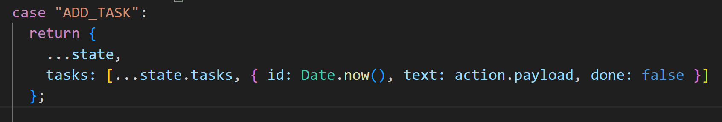
- Add the handleAddTask function as the onSubmit for the form
- Update the TOGGLE_Task case: 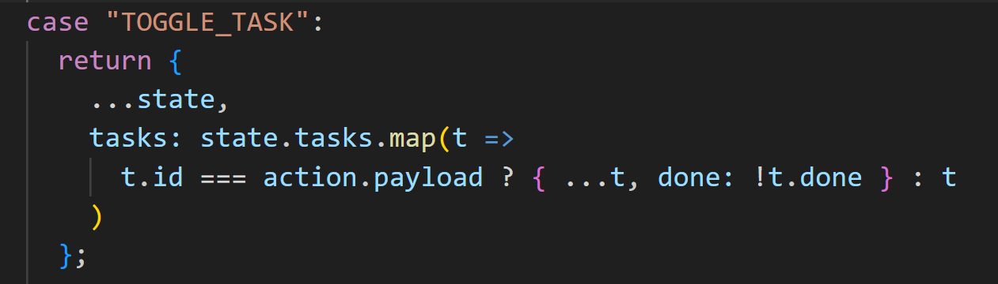
- call dispatch from the onClick of the li with type: “TOGGLE_TASK” and payload: task.id
- Update the CLEAR_COMPLETED case: 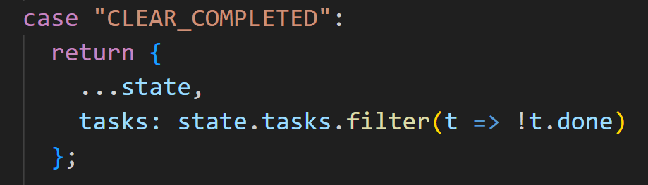
- call dispatch from the onClick of the clear button with type: “CLEAR_COMPLETED
- Test your TaskManager in the browserby running it using vite

This is the end of Quick Lab 1


